Heart Rate Monitor Final Report
Kin:Pathic
CAREBand
Maria Belhous (BME), Sydney Campano (BME), Raygan Matte (BME), Joudi Alkourabi (BME), Elle Underhill (EE), Ian Khoo (CE), Khang Pham (EE), Conor Ross (PLAS), Matthew Ha (PLAS)
Mentor: Prof. Steve Geyster (BME Faculty), Sean Webster, Prof. John Palma (EE Faculty)
04/04/2026
BMEN.4910

Executive Summary
There are currently no wearable systems designed to detect early signs of autistic meltdowns in children (aged 5-18) with autistic spectrum disorder (ASD). Without clinical intervention, frequent meltdowns can cause long-term burnout, increased anxiety, and physical harm [1]. Children and adolescents with ASD are nearly 40% more likely to self-injure due to overstimulation [2]. One study found that 90% of autistic children with sensory sensitivity also met clinical anxiety criteria [3], highlighting the need for a preventative solution.
A device capable of detecting the spike in heart rate that occurs prior to the peak of an autistic meltdown could provide clinicians and caregivers with an early warning queue, allowing them to remove or reduce the stimulatory triggers before a meltdown occurs. This could further help clinicians to understand what aspect of the environment may have caused the meltdown. Without intervention, repeated meltdowns can limit the child’s ability to be properly integrated into society, which negatively impacting the child’d development of social skills, increasing isolation, and ultimately leading to a poor quality of life [4].
The proposed solution, CAREband, is a novel wearable wristband designed to monitor heart rate and provide early detection of distress in children with ASD. CAREband uses a photoplethysmography (PPG) sensor that continuously measures heart rate and establishes an individualized baseline for the user. A real-time threshold-based detection algorithm identifies significant heart rate changes, defined as approximately a 20-30% increase above baseline, which are often associated with an autistic meltdown. Upon detection, the device emits an alert and wirelessly transmits data to the caregiver’s connected tablet.
Preliminary testing and validation demonstrated that the system could provide a warning message to the user interface following 3 consecutive HR readings that exceed the 22% threshold. However, HR data is highly susceptible to motion artifacts due to the quality of the PPG sensor utilized in the device. Due to this, there is an increased risk of false positive results or warning messages being sent without the HR exceeding the threshold.
Future work will focus on improving the accuracy of the PPG sensor, minimizing motion artifacts, as well as integrating the components onto a PCB board allowing for a smaller and more comfortable device.
Introduction
The CAREBand project focuses on the design and development of a wearable device that monitors heart rate to aid in predicting and preventing autistic meltdowns in children with autism spectrum disorder (ASD). The primary users of this system include caregivers, clinicians, and therapists responsible for monitoring and supporting children with ASD. The device will be a wristband that includes a photoplethysmography (PPG) sensor that can detect continuous heart rate data. This will allow for the identification of significant spikes in heart rate over a 22% threshold, indicating overstimulation or distress in children. The goal of this wearable device is to provide real-time notifications to caregivers and therapists, allowing them to intervene before a meltdown occurs. Ultimately, this CAREBand project addresses an important gap in the existing support systems that help in promoting safety and emotional regulation for children with ASD while reducing stress for therapists, clinicians, and caregivers. Given that children with ASD often experience difficulty expressing feelings of overstimulation and distress, devices like CAREBand are specifically valuable to enable the children’s caregiver or therapist to anticipate emotional dysregulation and meltdowns.
This report presents the design process and the reason behind main engineering choices including ergonomic considerations, sensor selection, materials selection, and data and signal transferring. Additionally, it outlines the testing and validation protocols used to ensure that the wearable device works safely, accurately, as well as comfortably for children’s daily use. It also highlights the physiological reasoning for heart rate monitoring as an indicator of stress response in ASD and the standards used to ensure regulatory compliance. Through a team made of interdisciplinary fields, the CAREBand project seeks to deliver a wearable, comfortable, and functional prototype that aims to improve the overall health and well-being of children with autism.
Project Definition
Client Information:
The sponsor for this project is Tiffany Remy, the CEO and founder of kin: pathic, an ABA (Applied Behavior Analysis) therapy program. Remy is currently a BCBA (Board Certified Behavior Analyst) and holds graduate degrees in Mental Health Counseling and Early Education Policy. Remy, along with partner Cylvia Masoni, started kin: pathic to support children with autistic spectrum disorders by providing spaces that children enjoy, while learning and gaining skills they need to flourish [1].
Kin: pathic currently offers in-center based ABA, home-based ABA, remote sessions, and school-based programs, ranging from 18 months-18 years of age. Each child has a specific learning plan based on their specified needs that is determined by the school's learning model and services they require. The center has a 1:1 child to BCBA ratio, which offers many benefits such as, individualized attention, tailored treatment plans, effective skill acquisition, managing challenging behaviors, enhanced supervision and feedback, and a generalization of skills [2]. Learning these skills at a young age helps the child transition into public schooling, as well as becoming more independent.
Project Concept:
The client proposed a wearable device that the children at the kin: pathic center can wear, that can detect and alert a clinician before an autistic meltdown takes place. It was recommended that the wearable be a wristband, as due to experience it is the most likely wearable that the students will keep on. As well as the parameter used to detect the autistic meltdown be heartrate, as prior research has shown an increase of heartrate before a meltdown occurs.
The deliverables that will be given to the client will consist of the wearable and a receiver. The wearable will be composed of a wristband and an electrical component included with sensors to detect the child’s heart rate. The receiver will include a device with a screen where the information from the wearable can be displayed to the clinicians.
The main benefit of this product is that it will prevent autistic meltdowns, which are not only dangerous for the child, but also for the clinician paired with them. Due to ASD communication is often very difficult and they cannot always articulate that they are overstimulated, this makes ASD meltdowns often seem very random. During a meltdown reactions feel uncontrollable and irrational, making their actions harmful to themselves and others around them [3], [4]. Predicting when a meltdown is going to happen allows a trained clinician to intervene, reduce any sensory triggers and stressors, and stop the meltdown from occurring.
Problem Statement
Children with ASD may be unable to communicate with caretakers about their state of emotional regulation, which can potentially lead to further stress that causes an autistic meltdown. Therapists desire a wearable band that can detect increases in stress to prevent escalation.
Objective Statement
To design and build an assistive wearable heart rate monitor for children with ASD that can accurately and timely detect and alert therapists of significant spikes in heart rate (less than or equal to 22% above baseline), indicating overstimulation and stress to aid in preventing ASD meltdowns, with testing and validation within the project’s timeframe [16].
Research
Autism spectrum disorder (ASD) is a neurological disorder caused by genetic and environmental factors; the disorder is distinguished by several behavioral elements including social communication, repetitive behaviors, and restricted interests. The diagnoses are classified as a range based on severity and how present the symptoms appear [5].
Every diagnosis is unique as symptoms differ for each child, as well as severity. However, there are common symptoms and patterns in behavior that help clinicians determine an accurate diagnosis for each patient. Many of the common symptoms include, not being responsive, independency, poor eye contact, lack of expression, failure to speak, delayed speech, avoiding conversation, speaking with an unusual tone/rhythm, repeating words, avoiding showing emotion, and can be passive/aggressive/disruptive with others. Along with these symptoms, there are also many common patterns that can be identified such as, repetitive movements, trying to harm themselves, uncoordinated, unusual/stiff/exaggerated body language, fascination by details of objects, sensitivity to light/sound/touch, preferring specific foods, and fixation on an object or activity. Beyond the behavioral symptoms and patterns, there are also nerve patterns as children with ASD have abnormal reaction to pain perception, tactical stimulus, and lower motor skills [6].
These symptoms are used to establish an ASD diagnosis and calculate what level of the condition they have. Autism is organized into multiple levels of severity based on core symptom domains. DSM5 criteria evaluate severity based on the core symptoms and level of support needed [1]. The three levels of severity range from requiring support to requiring very substantial support. Level 1 is where the individual has difficulty initiating and is unsuccessful in social response and without support it can result in visible impairment. Level 2 with support, there are social impairments present. Level 3, the individual has very limited social response and severe deficits in verbal communication which leads to overall impairment in function [1]. The basis of this assessment (DSM5 criteria) was found to be not sufficient as it did not account for associated conditions and a more multidimensional system needed to be developed to take each individual's support needs into consideration [1]. Some research standardized tools used to diagnosis autism are Childhood Autism Rating (CARS), Autism Behavior Checklist (ABC), Autism Diagnostic Interview Revised (ADI-R) and Autism Diagnostic Observation Schedule (ADOS). The ADI-R includes an in-depth clinical interview on the individual's current and past behavior [1]. In addition to this tool, ADOS can be used to evaluate autistic symptoms based on behavior through clinical observation. There are five versions of ADOS each optimized to the individual's age and functioning, so the individual has the best version adapted to their ability. This tool produces autistic severity evaluations based on the symptoms observed, using a calibrated severity score. This ten-point system provides ratings for individuals of a similar age and with similar language abilities. It works to efficiently produce measures in a nonbiased form of testing where it limits other characteristics from impacting symptom evaluation [1].
One of the most common behavioral problems that children with autism spectrum disorder face is an ASD meltdown. An ASD meltdown is a physical release of emotion due to sensory overload or high stress levels, where emotions come out in an uncontrolled, involuntary, explosive manner [3], [4]. Some of the triggers for these meltdowns include loud noises, bright lights, crowds, strong smells, and chaotic environments. Before a meltdown, a child may start to feel increasingly agitated and overwhelmed, but due to their lack of communication skills they cannot alert someone with how they are feeling. This may arise unexpectedly or be built over a long period of time to the point where they can no longer cope. This sends a child into a meltdown; this may look like screaming, crying, pacing, rocking back and forth, self-harming, repeating movements, and unrationed reactions. The duration may be short or last for hours, after children often feel remorse, embarrassment or confusion. To deal with these feelings, it is important to allow time to calm down by reducing their sensory overload. This can be done by finding a quiet, dark place to rest, or using tools such as noise canceling headphones, calming music, and snacks [3].
Autistic meltdowns can be very dangerous as the child has a lack of control; it puts a significant risk of harming themselves and others. Children may often self-harm by biting or hitting themselves or banging their head off objects; it is also physically intense and leaves the child exhausted [7]. Caregivers such as parents, family members, teachers, doctors, are also at risk due to these meltdowns as the child often lashes out on people who may be trying to help. Siblings are also high-risk individuals as they are often still young and do not understand what is happening or the severity; they may often get in the way or intervene and become hurt accidentally during the process [7], [8]. Autistic meltdowns are a huge problem, and there is currently no way to predict when they may happen.
Furthermore, the physiological effects that an autistic meltdown has on a patient can be severe. One of the most prominent effects that such a meltdown may have on a person is an increased heart rate and a decrease in the variations in the time intervals between consecutive heartbeats (known as the heart rate variability) [9] .The build-up to an autistic meltdown has the same physiological effect as a severe stress response has on a neurotypical person; therefore, the pupils may dilate, skin sweats, and the face heats up [9] . This occurs due to the quick response triggered by the sympathetic-adreno-medullar system (SAM), where an increase in the secretion of norepinephrine and epinephrine is released by the adrenal medulla [10]. These hormones enter the circulatory system and bind to α- and β-adrenergic receptors in the central nervous system, which triggers a cellular cascade that results in the rapid activation of cells [10]. This leads to the contraction of smooth and cardiac muscle cells, which causes vasoconstriction (increased blood pressure), an increase in heart rate and heart contractility in the cardiac ventricles (increasing cardiac output), thermogenesis (increase in the production of body heat), and increased oxygen consumption [10]. Therefore, the proposed solution aims to utilize biosensors to predict an autistic meltdown prior to occurring.
Currently there are an immense number of commercially available heart rate monitoring wearable devices. Namely the large distributors of these devices include that of the apple watch, and Fitbit. However, these top brands typically aren’t marketed towards children with autism and don’t consider the specific needs that this population faces. Such as specific sensory considerations, durability, and sanitation needs. However, some brands have embraced these considerations within their design and have a very similar goal or solution to our overall goal of safe and effective heart rate monitoring to predict meltdowns prior to their peak.
One of which is known as the Empatica EmbracePlus watch, which was originally developed to aid individuals with autism monitoring their emotional status as a prediction device [11]. This device is currently still utilized in research pertaining to this cause. This device is extremely versatile from its hypoallergenic wristband design to its waterproof interface [11]. The sensor pod is roughly 44mm in size and wirelessly connects to an app which allows for non-stop data recording [11]. Along with heart rate, it utilizes a temperature sensor and electrical conductance sensor to detect subtle changes in compensatory efforts [11]. This device leverages the fact that slight increases in skin conductance is indicative of emotional arousal, as well as an increase in HR to help predict when an emotional outburst may occur (although this would ultimately be interpreted from a caregiver as this device only displays data) [11]. However, a major downside to this device is its extremely expensive cost which is roughly $1,080.00 along with a roughly $50 a month subscription cost [11].
Currently the only commercially available HR monitoring device specifically marketed for people with autism spectrum disorder is the Empatica EmbracePlus watch. However, many academic researchers have developed similar devices which aren’t commercially available. Among others, a study conducted by Goodwin et al. found that physiological signals captured by a wrist-worn biosensor were used to predict aggression in individuals with ASD [12]. However, no commercially available device has been produced or marketed for people with ASD following such studies.
Although not marketed specifically for those with ASD, the most recent model of the Fitbit (known as the Fitbit Charge 6) includes in-depth tracking metrics for consumers that align with the goals of CAREBand. Such as a life ECG on the interface, GPS, HR monitoring, and skin temperature readings while also being swim proof and having a battery life of 7 days [13]. This is a much cheaper option, roughly $160, when compared with the Empatica EmbracePlus watch. Similarly, the apple watch series 11 (most recently available) includes even more in-depth metrics for the consumers [14]. Which includes hypertension notifications (blood pressure monitoring), ECG display, blood oxygen (SPO2) data, fall detection, and temperature sensors [14]. However, this device is around $800, which is significantly more expensive than Fitbit. In addition to the Fitbit and apple watch series 11, the Oura Ring 4 presents as a popular biometric device that obtains data on heart health (heart rate, heart rate variability, Vo2 Max, cardio capacity, cardiovascular age), body temperature, stress levels (stress resilience, HRV), women's health (cycle tracking, pregnancy insights) and sleep tracking (includes timing between 4 sleep stages, when you started sleeping and when you woke up, calculates sleep score + tracks blood oxygen) [15] . The ring can range from $349 to $499 with a membership that costs $5.99 monthly or $69.99 annually [15]. Ultimately, the current solutions are extremely expensive, and do not include features that are able to identify and predict an autistic meltdown proving ineffective in providing a solution to the proposed problem.
Requirements
Table 1. Shows the in-depth requirements of the devices organized into specific topics.
ID Number | User/Stokehold Need | Requirement | Classification | Owner | Verification Method | Test Procedure | Test by Date | Accept by Date
1.0 General | Device provides reliable HR monitoring of HRs between 30-210 BPM | Device will have a % error of <10% (this % error is based on clinically accepted wrist HR monitoring devices) [17] | Safety / Performance | Biomed and EE | In a lab setting, the device's HR performance will be tested against the medical gold standard for HR monitoring (ECG) | VER-HR-001 | Beginning of spring semester
2.0 Function & Features | Detects increase in heart rate and sends a warning response to clinicians | Warning is sent to clinician's interface when the heart rate increases by 22% | Performance | Biomed and EE | In a lab setting, participants' HR will be increased via exercise on an exercise bike; alarm/warning system will then be tested. Results will be tested against the medical gold standard for HR monitoring (ECG) | VER-HR-001 | By end of Fall Semester
 | Can withstand everyday wear for active children | Device will be sturdy enough to withstand daily hand movements and mobility | Functionality | Biomed and EE | User trial | VAL-001 | By end of Spring Semester
 | Device will account for physiological differences among patients | Device will include a normalization process during set-up | Performance | Biomed and EE | In a lab setting, participants will remain still and at rest for at least 5 minutes, and baseline data will be collected by the device and the gold standard ECG; the data will then be compared for verification. | VAL-001 | By end of Fall Semester
 | Device will not falsely provide the warning message to technicians | Device will display a warning message when 3 consecutive HR readings exceed the 22% threshold | Performance/functionality | Biomed and EE | In a lab setting, participants' HR will be increased via exercise on an exercise bike; alarm/warning system will then be tested. Results will be tested against the medical gold standard for HR monitoring (ECG) | VER-HR-001 | Completed on 4/8/26
 | Device will be evaluated based on user input for improved modifications | Device will meet CAPA requirements for user evaluation | Performance/Safety | Biomed | User trial | VAL-001 | By end of Spring Semester
3.0 Ergonomics & Physical | Device should be comfortable and not disruptive to daily tasks | Wristband should be composed of a material that is smooth and doesn't retain heat (to prevent sensory overstimulation for the patients). | Usability | Biomed and Plastic | User trial | This will be field tested, via user feedback/surveys | By end of the fall semester
4.0 Data | Compliance with HIPAA Laws | Device should include technical safeguards to ensure patient confidentiality | Functionality/Safety | EE/ECE | Verification method needs to comply with ISO/IEC 27701:2019, especially when involving minors | Test procedure will be drafted based on ISO/IEC 27701:2019 | By end of Fall Semester
 | Follows software life cycle requirements | Device should have risk management documentation | Functionality/Safety | EE/ECE | Verification based on ISO 14971 and IEC 62304: Software development plan lined with traceability (design, code, tests, and risk controls) and early error detection with requirements clear and testable | Test procedure through troubleshooting software and making sure error detection and patient data protection is active based on standards and tests in place | By the end of spring semester
 | Clinical data storage | Device shall store and export 24 hours of heart rate data | Functionality | EE/ECE | Data obtained from previous in lab experiments will be utilized to verify that the device has the capacity to retain data for 24 hours | Protocol will be tested to verify data retention: that stored records remain readable, intact, and uncorrupted for up to 24 hours | By end of Fall Semester
5.0 User Interface | Easy to read/understand | Device indicates the objective heart rate (in bpm) and a warning component when the threshold is exceeded | Usability | Biomed and EE/ECE | User trial | This will be field tested, via user feedback/surveys | By the end of spring semester
 | Includes a more rigorous interface for highly specialized clinicians | Device shall include an EKG-like styled graph | Usability | Biomed and EE/ECE | User trial | This will be field tested, via user feedback/surveys | By the end of spring semester
 | Interface includes a warning display to inform them of when the device is no longer within the Bluetooth range | User interface should include a vibration and visual warning when Bluetooth receiver (user-interface) and wristband are no longer within range 35 feet. | Usability/functionality | Biomed/EE | Lab verification testing. | Verification will be completed by separating the receiver and transmitter by >35 feet to ensure warning appears. | By the end of the spring semester
6.0 Refurbish/Recycle | Compliance with sustainability | Device shall be designed for end-of-life recycling per WEEE directive | Regulatory | Biomed and plastics | N/A | N/A | N/A | N/A
 | Device can be used for multiple patients | The device should be able to be reprocessed, revalidated, and withstand surface disinfection to be utilized for multiple patients | Regulatory | Biomed and plastics | In the lab setting, the device will be subject to disinfection through an aerosol spray, and wipes. The device will then be tested on a participant to ensure that surface disinfection doesn't impact performance | Test protocols will be drafted to include validated cleaning products/methods that consumers can use to disinfect the device without damaging any electrical components. | By the end of spring semester
7.0 Packaging/Labeling | Regulatory compliance | Labeling shall meet FDA requirements | Regulatory | Biomed | Documentation Review
 | Safe transport | Packaging shall protect device from damage in 1m drop test | Safety | Biomed | Drop Test | Testing procedure follows: IEC 60601-1 | By the end of spring semester

Technical Details and Analysis
Analysis of Multiple Design Choices:
TABLE 1: RESEARCH ORGANIZED IN A PRO AND CONS LIST FOR POTENTIAL WRISTBAND MATERIAL
MATERIAL | PRO | CON | SCORE
POLYURETHANE [21], [22] | - Great wear resistance  - Good tensile and abrasion strength  - Great impact strength  - Good chemical resistance  - Biocompatible resin options | - Releases volatile organic compounds when processed (can be minimized with fume hoods)  - Processing can be tricky as polyurethane notoriously has ejection problems (the part gets stuck the mold during processing)  - Can degrade with exposure to UV or high heat. | 2
SILICONE RUBBER [23], [24] | - Excellent temperature resistance (maintains properties from around –60 degrees Celsius to 230 degrees Celsius)  - Good flexibility  - Good electrical, water, UV, chemical, and ozone resistance  - Biocompatible-nontoxic and non-hypoallergenic | - Processing can be difficult as it is completely different from the processing of typical thermoplastics (LSR starts as a liquid and then is cured into a solid as opposed to normal resins which are melted from a solid into a liquid and then cooled to shape.  - When the material fails, it is usually a catastrophic failure (complete breakage and serious enough damage that the part will not function as intended. | 2
MEDIPRENE [25] | - Good flexibility  - Good resistance to healthcare fluids  - Biocompatible  - Good heat resistance  - Easy processing | - Is not resistant to organic solvents, aromatic oils, or vegetable oils.  - Low tear and abrasion resistance. | 3

TABLE 2: RESEARCH ORGANIZED IN A PRO AND CONS LIST FOR POTENTIAL PROTOTYPE BATTERY AND RECEIVER TYPES
PROTOTYPE BATTERY VARIATIONS

BATTERY TYPE | PRO | CON | SCORE
NIMH CELL BATTERY | - Rechargeable  - Common  - Always has full capacity | - More Expensive  - Large | 1
LI-ION | - Rechargeable multiple times | - Needs special charger  - Not available in standard voltages | -2
NICD | - Older  - cheaper | - Lower voltage outputs | 1
QI WIRELESS CHARGER | - Wireless charging  - Long term cost efficient | - May interfere with sensor  - Can make it more complex | 0
MAGNETIC CABLECHARGER | - Easy to use  - Rechargeable  - Long term cost efficient | - Patented: [26] | 0
RECEIVER TYPE VARIATIONS

RECEIVER TYPE | PRO | CON | SCORE
RECEIVER WITH DISPOSABLE BATTERIES | - Portable  - Simplest circuitry | - Need to be able to access batteries and take apart device – not very user friendly | 1
RECEIVER WITH RECHARGEABLE BATTERIES | - Portable  - User friendly | - More complicated PCB required | 1
RECEIVER THAT PLUGS INTO OUTLET | - Simple circuitry | - Not portable | 0
PHONE APPLICATION | - No new physical receiver will have to be developed  - No expenses  - User friendly  - More reliable – no mechanical problems to go wrong | - Requires more programming  - Won’t be up kept | 2

TABLE 3: RESEARCH ORGANIZED IN A PRO AND CONS LIST FOR POTENTIAL PROTOTYPE MAIN DEVICES
BATTERY TYPE | PRO | CON | SCORE
SCREEN WITH EKG | - Easy to look at and visualize  - Will always be with client | - More Expensive  - Large  - Can break | 1
SINGULAR POWER BUTTON | - Simple and easy  - One button is less points of failure | - Not as much accessibility on main device | 3
ALLOW MAIN DEVICE TO CALCULATIONS | - Keeps code centralized  - Less data transfer needed | - More taxing on the main microchip  - More usage of limited battery | 0

TABLE 4: RESEARCH ORGANIZED IN A PRO AND CONS LIST FOR POTENTIAL PROTOTYPE SOFTWARE
BATTERY TYPE | PRO | CON | SCORE
ARDUINO IDE | - Easy to program  - Well documented | - Larger physical parts | 2
ZEPHYR RTOS | - More easily read by machine  - Real-time, runs more efficiently  - Similar to C language  - Lots of documentation | - Standalone language | 4
ALLOW MAIN DEVICE TO CALCULATIONS | - Keeps code centralized  - Less data transfer needed | - More taxing on the main microchip  - More usage of limited battery | 1

Scoring is based on the differences in pros and cons to determine which viable option has more pros. The pros and cons list was based on the universal design criteria (Elegance, Robustness, Aesthetics, Cost, Resources, Time, Skill Required, Safety).

Chosen Solution:
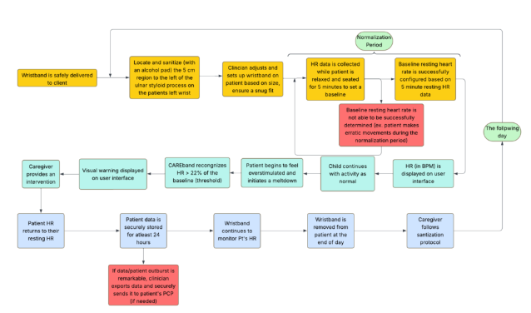
Figure 1. Process map outline for wristband preparation and usage
This map discusses steps from wristband delivery to set up patients. It includes visualization of data collection and ultimately data output.

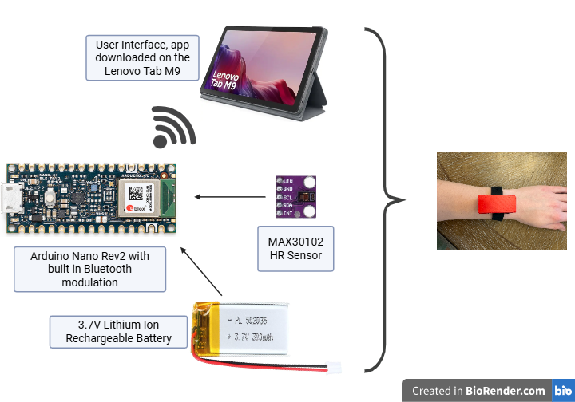
Figure 2: Electrical Components chosen and how they Integrate into the circuit.
The method for charging the device would be using a USB-C type connection to charge the internal lithium polymer battery. That charger would also go to the power management integrated circuit (PMIC), which would ensure that there is no overload in voltage going through the circuit. From the PMIC, the voltage is outputted to the sensor as well as the microcontroller. With the built-in Bluetooth compatibility in the microcontroller, it is possible to output the data from the sensor to the receiver, where it would output the results from the sensor.

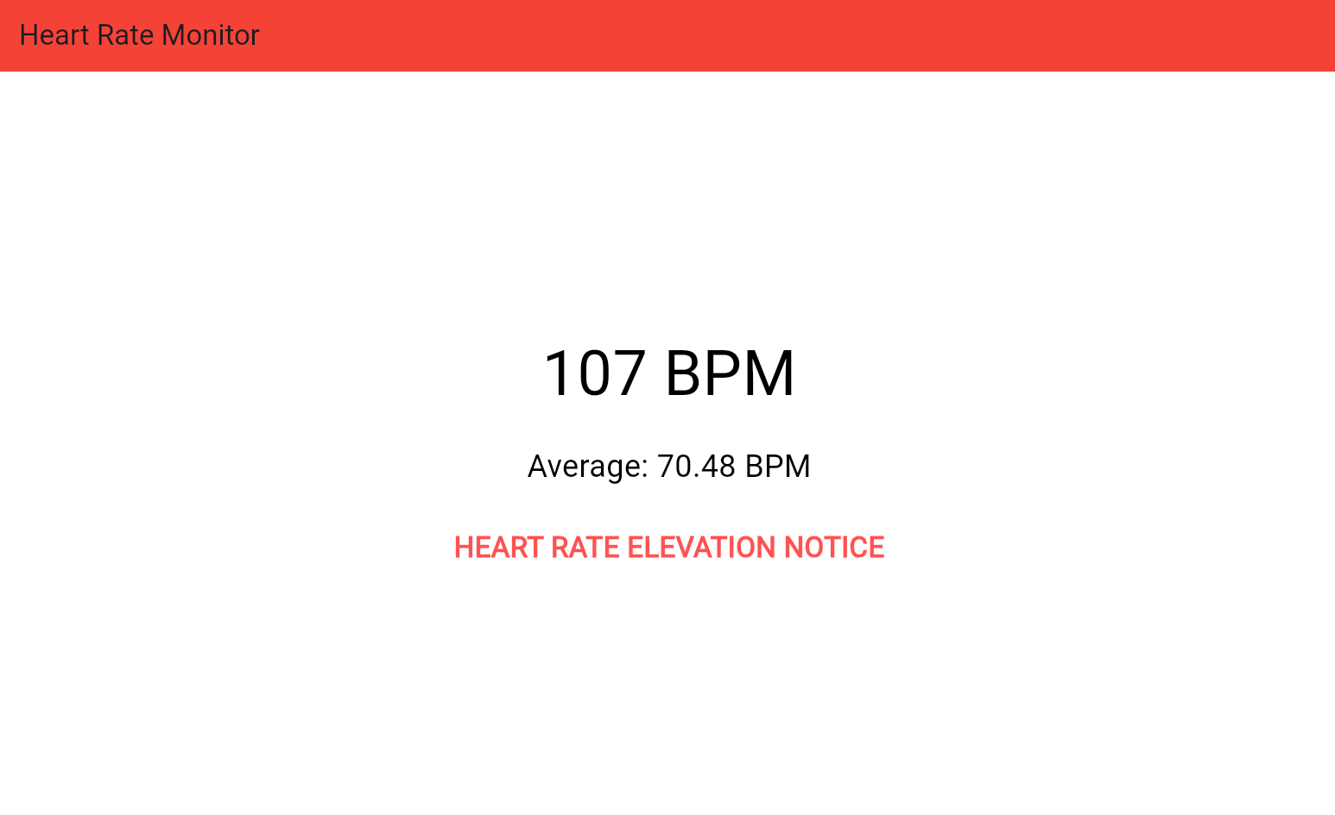
Figure 3: Flutter App Receiver.
Two apps, as shown in Figure 3, were developed through Flutter, which uses Dart as the programming language, and they were downloaded onto the Lenovo tablet to be the receiver or user interface. One app was created to automatically connect to the nRF microchip prototype, and another was made to connect to the two Arduino prototypes, which ended up being our final solution. However, both apps perform the same function of pairing through Bluetooth, reading live heart rate data, displaying the current heart rate and calculated rolling average, and provide a heart rate elevation notice when the current rate rises to 22% above the average, as shown in Figure 3.

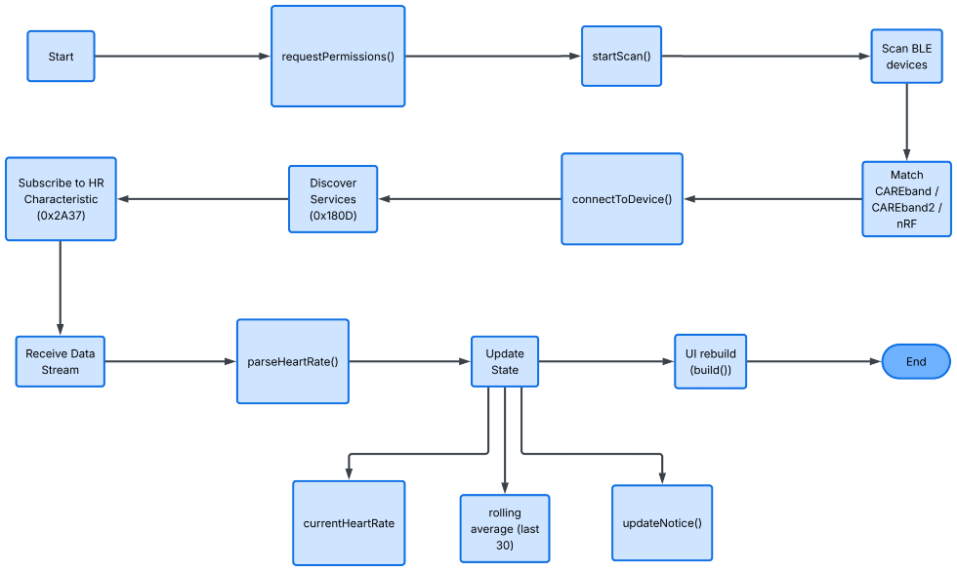Figure 4: Flutter App Code Breakdown.
Figure 4 shows the process map of the code for the downloaded Lenovo app receiver, which is shown in Figure 3. To start, the app boots up on the tablet. Then it requests Bluetooth permissions and starts scanning for devices. Then it matches and connects with one of the devices and discovers the services that the device offers. It then subscribes to the heart rate characteristic and receives the data and parses the heart rate, meaning it turns the Bluetooth data into a readable heart rate number. Then it updates the current and average heart rate and checks if an elevation notice is required. Lastly, it updates the user interface screen and resets when you close out of the app. The code also contains information about the aesthetics of the app, such as the font and coloring, which is not mentioned in this flow chart but can be viewed in Figure 3.

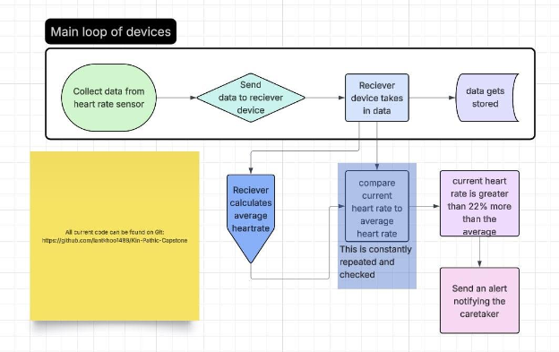
Figure 4: Process map of main components of software.
The basic software plan for the device is shown Figure XX. The plan is to have the main device on the patient, and all that it will be used for is gathering and sending data. Upon startup, the device will run Setup() which initializes the device, and it will start Benchmark() which will find the average heartrate of the child. Utilizing the heart rate sensor, it will gather a heart rate and send it to the main receiver. This is done through the GetHeartRate() and SendData() functions. The receiver will do the math and calculations to determine if the client is about to begin a meltdown. If a meltdown is about to occur, it calls upon AlertParent(). AlertParent() will have the functionality to change the meltdown threshold from 22% to higher or lower depending on patient needs. In addition to this, the receiver also will display an EKG graph to show the heartrate over a span of 10 minutes, done by DisplayHeartRate(). Finally, the receiver will hold on to the previous day’s data on an SD card. The language to be used is the Zephyr real time operating system (RTOS) which is similar to the C coding language. Zephyr will be coded and implemented using Microsoft Visual Studio Code (VScode), as it has a coding enviorment and allows for easier debugging and testing. The main device was chosen to do as little calculations and math as possible to save on battery life and to make all other operations on the chip as efficient as possible.
All code for the project is available at: https://github.com/iantkhoo1488/Kin-Pathic-Capstone
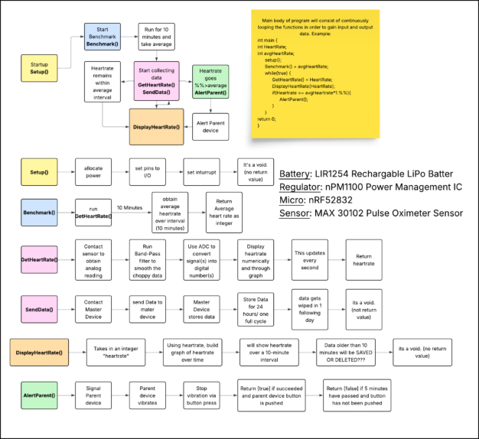
Figure 5: Process map Outline for software.
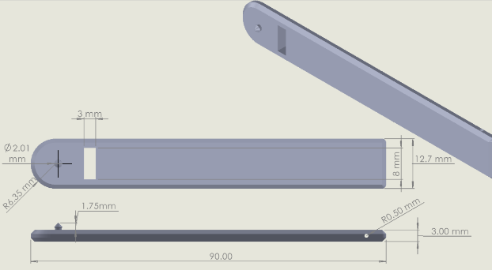
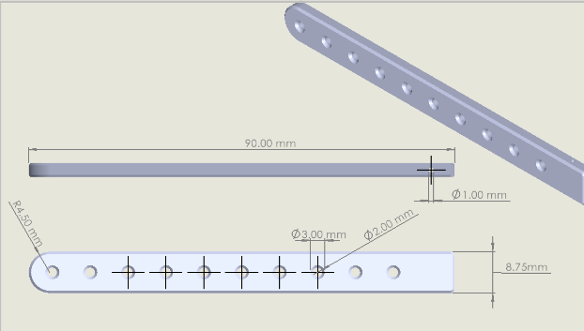
Figure 6: CAD drawings of wristband configuration, please note that this wristband was not utilized in the final CAREband design which utilizes KAHADI Store Waterproof AirTag Bracelet due to user comforbility.

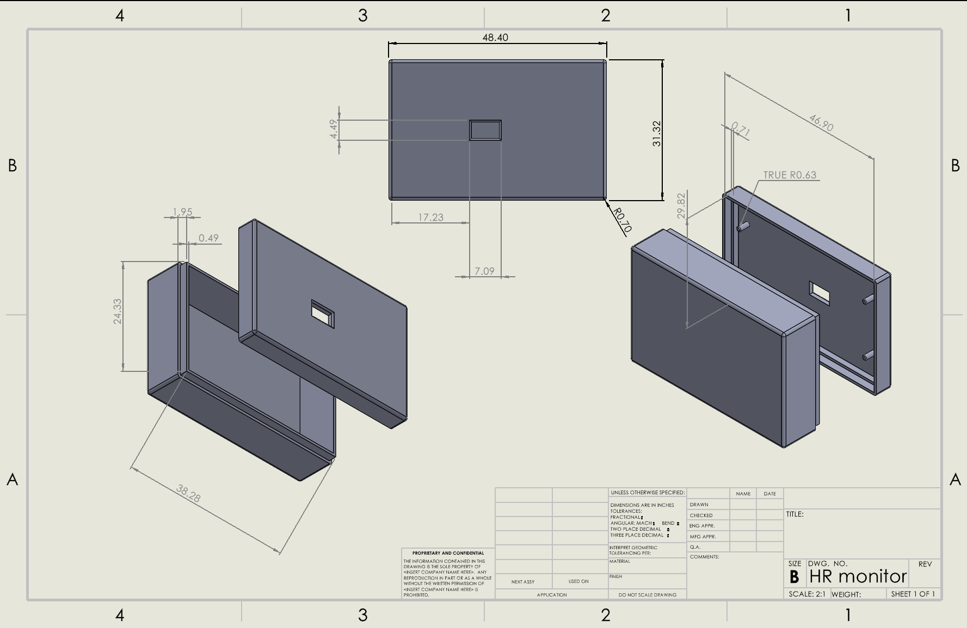
Figure 7: CAD drawings of the housing compartment for the electrical components

The wristband measurements were based on the size of an apple watch and Disney child size wristbands, as well as including an adjustable component to ensure an optimal fit for each child. The housing was created based on the estimated size of the PCB board; however, it will be updated when the measurements are finalized.
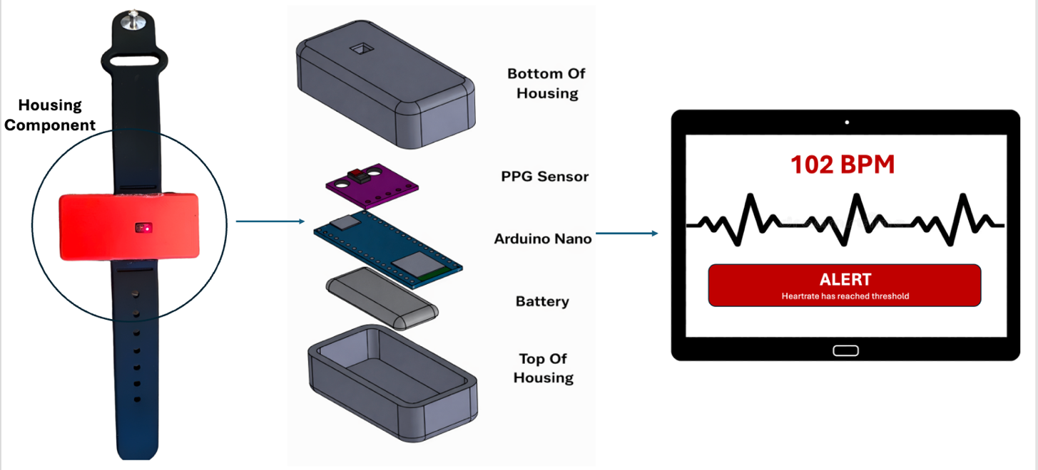
Figure 8: Shows components including the user interface, handheld receiving device for the clinician, and wristband/housing wearable.

The transmitter would be worn by the patient, which would be fastened to the patient's wrist (with the main compartment about 1 cm to the left of the ulnar styloid process) with the Mediprene wrist band that is both comfortable for the patient and practical. Heart rate and S_{p}O₂ sensors would be housed in the main compartment of the wrist band wearable device. The portable, handheld receiving device would consist of a touchscreen interface that includes both an ECG and S_{p}O₂ displays so that the clinician can get a big picture in the understanding of the patient’s status. Furthermore, alerts will be displayed on the center/middle of the interface, and the entire device will vibrate to alert the clinician if metrics exceed the threshold.

Design and Analysis:
PPG Sensor
The photoplethysmography sensor that was utilized for the device was the MAX30102 Low Power Heart Rate Click Sensor. This allows CAREband to read and transmit heart rate data through just having contact with the user’s wrist. The MAX30102 sensor is a type of reflective photoplethysmography (PPG) sensor with a breakout board. There are two modes of PPG, transmissive and reflective; in transmissive-mode PPG, the light has a straight optical pathway through the dermis, muscle, and bone, and then through the muscle and dermis to reach the detector on the opposing side. Transmissive photoplethysmography is based on the principle that the amount of light detected by backscattering after irradiating the skin significantly changes according to cardiac activity [18]. This is based on Hertzman’s theory, which suggested that PPG can measure blood volume changes in microvasculature for a specific area when irradiated with light [18].
Pulsation, the heart-synchronized variations in blood volume within the tissues, mediates the changes in concentrations of substances in the blood, thereby affecting the optical path and light transmitted or reflected, which is measured by PPG sensors. Mathematically, this is explained by the Beer-Lambert law, which states that I = I₀e^{−εlc}, where transmitted light intensity (I) will exponentially decrease in light intensity (I₀) in relation to the optical path length (l), absorption coefficient (ε), and concentration of the medium (c). Absorbance, the measure of light attenuation as it passes through or reflects off tissue, is depicted as the exponential term in the Beer-Lambert law or A = −εlc. In clinically deployed PPG biosensors, the Beer-Lambert law is used to calculate oxygen saturation within the blood, which is known as SPO₂ [18]. Figure XX shows the differences between the sensor and detector setup for reflective (right) and transmissive (left) PPG sensors.
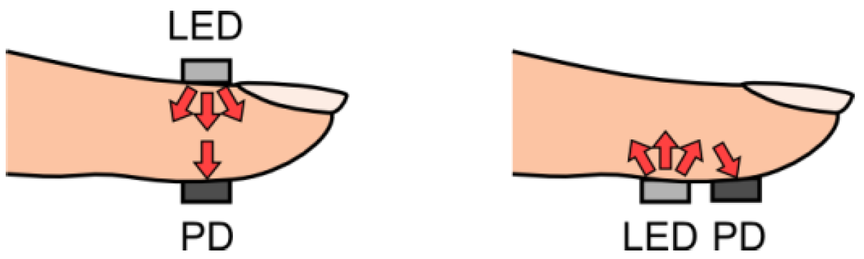
Figure XX. Shows the sensor and detector setup for reflective (right) and transmissive (left) PPG.
On the contrary, reflective PPG follows a nonlinear pathway as the path between the emitter and the photo detector is curved. This results in multiple canoe-shaped light waves that scatter and bounce as they curve through the tissue to the photodetector. The original Beer-Lambert law cannot be directly applied as it requires the light to travel in a straight line through a uniform solution. Therefore, a modified Beer-Lambert equation, absorbance then becomes A=μ λ ⋅l_{effective,} where represents how strongly the tissue absorbs light, and l represent the canoe-shaped average path of the light [18]. Each curved path can be divided into segments where each represents a different component of tissue, such as skin (dermis and epidermis), arterial blood, and venous blood. The total absorption then becomes the sum of the absorption from each of the tissue segments. Absorption is determined by how strongly each molecule absorbs light (ε) and how much of that molecule is present (c). This is mathematically depicted as 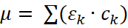 [18]. As pulsation occurs, arterial blood volume increases, which increases the amount of hemoglobin present, resulting in changes in absorption and therein changes in detected light intensity, which is recorded during reflective PPG. Due to light scattering, the path of light from the LED to the photodetector is longer than the physical distance, which is then mathematically corrected using a differential path length factor [18]. The breakout board that is included within the MAX30102 heart rate sensor is responsible for computing these calculations.
The main code for the heart rate monitor was done in VSCode using ZephyrRTOS language. The NRFConnect, Workbench for Zephyr, Zephyr IDE, and Device Tree editor extensions were used. As stated above, the main use of the main device was just to collect data from the heart rate monitor, convert it into transferable data, then send it to the parent device. This is done using the I2C lines on the Heart rate monitor into the main chip of the NRF-52.
List of all versions of the HRM software (NRF-52DK) and what was changed:
Version | Files Changed | Changes / Improvements
v1 | All files (initial) | Initial project creation. Basic MAX30102 driver with zero-crossing HR algorithm. Simple BLE Heart Rate Service using BT_LE_ADV_CONN_NAME macro. Old devicetree overlay using sda-pin/scl-pin syntax.
v2 | overlay | Fixed devicetree overlay for NCS v2.x+. Replaced deprecated sda-pin/scl-pin with pinctrl syntax using NRF_PSEL macros. Added i2c0_default and i2c0_sleep pinctrl states. Removed deprecated label property from MAX30102 node.
v3 | prj.conf | Fixed Kconfig parse errors. Removed inline comments from CONFIG_BT_DEVICE_APPEARANCE and CONFIG_LOG_DEFAULT_LEVEL — Kconfig does not allow inline comments on integer values. Added CONFIG_PINCTRL=y.
v4 | ble_hrs.c | Fixed BT_LE_ADV_CONN_NAME undefined error. Replaced deprecated macro with explicit bt_le_adv_param struct using BT_LE_ADV_OPT_CONNECTABLE. Added separate sd[] scan response array carrying device name.
v5 | ble_hrs.c | Fixed BT_LE_ADV_OPT_CONNECTABLE undefined error (also renamed in NCS v3.x). Replaced with BT_LE_ADV_OPT_CONN. Added forward declaration for start_advertising(). Moved device name into ad[] array.
v6  (This was the first working version) | All files | Full audit and rewrite for NCS v3.2.4. Replaced bt_conn_cb_register() with BT_CONN_CB_DEFINE macro. Removed deprecated label properties. Fixed all inline Kconfig comments. Removed VLA in HR algorithm — replaced with static buffer and running prev variable to avoid stack issues on embedded target.
v7 | max30102.c, max30102.h, main.c | Major algorithm upgrade. HR algorithm replaced with Pan-Tompkins inspired pipeline: DC removal → derivative → squaring → moving-window integration → adaptive threshold peak detection → mean inter-peak BPM. Added signal quality check (AC/DC ratio / perfusion index proxy). Added finger presence detection via IR threshold. Added 5-reading BLE smoothing buffer with spike rejection (20 bpm threshold). Added sliding window — keeps last 50% of samples between calculations. Rate-limited BLE notifications to every 3 seconds. Added 4x hardware FIFO averaging reducing effective rate to 25 sps.
v8 | prj.conf | Attempted fix for BLE Error 133 (GATT error on connect). Added BT_BUF_ACL_RX/TX_SIZE=251, BT_L2CAP_TX_BUF_COUNT=6, BT_CONN_TX_MAX=6. Added BT_GATT_SERVICE_CHANGED, BT_SETTINGS, FLASH, FLASH_MAP, NVS for bonding persistence. Disabled BT_PRIVACY to fix nRF Connect app re-pairing issues.
v9 | prj.conf, ble_hrs.c | Root fix for Error 133. Stripped flash/NVS/settings stack (was causing boot fault). Disabled BT_SMP — no pairing needed for HRM. Added MTU exchange request immediately on connect via bt_gatt_exchange_mtu() in on_connected() callback — the primary fix for Android/iOS dropping connection during GATT discovery.
v10 | prj.conf | Fixed linker error: undefined reference to bt_gatt_exchange_mtu. Added CONFIG_BT_GATT_CLIENT=y — this symbol lives in the GATT client subsystem and is required even when used from a peripheral.
v11 | main.c | Fixed one-shot update issue. Removed sliding window (was mixing stale data). Removed BLE rate limiter (BLE_NOTIFY_INTERVAL) and changed check. Buffer now resets fully to zero after every calculation window. BLE notified on every valid result.
v12 | main.c | Fixed FIFO polling race condition. Replaced single-sample polling every 40ms with full FIFO drain loop every 200ms. Inner loop reads until got==0 (FIFO empty). Collects all pending samples in batch rather than risking timing drift with one-at-a-time reads.
v13 | max30102.c, max30102.h, main.c | Root fix for unreliable FIFO reads. New max30102_drain_fifo() reads WR_PTR, OVF_COUNTER and RD_PTR in a single I2C burst transaction to eliminate race condition between separate pointer reads. Calculates available samples with correct circular wrap at 32. Reads all samples in one second burst. Poll interval increased to 500ms. main.c updated to call drain_fifo() instead of read_sample().
v14 | max30102.c, max30102.h, main.c | Removed all finger detection and signal quality gating. No more finger threshold check, quality check, spike rejection, or smoothing history. Algorithm always runs and always sends a result. Simplified main loop: drain FIFO every 500ms, fill buffer, run algorithm, send result, reset.
v15 | main.c, ble_hrs.c, ble_hrs.h | Added onboard LED status indicators. LED1 (P0.17): solid on at boot as power indicator. LED2 (P0.18): blinks at 1Hz while advertising/waiting for connection. LED3 (P0.19): solid on when BLE central is connected. LED4 (P0.20): flashes 80ms on each successful BLE notification. LED2/LED3 managed by background ble_blink_thread. Added bt_hrs_is_connected() to ble_hrs API. Used deprecated device_get_binding() — fixed in v16.
V16  (Current)  (also ported to Arduino) | main.c | Fixed LEDs not turning on. Replaced deprecated device_get_binding("GPIO_0") with GPIO_DT_SPEC_GET using DT_ALIAS(led0..led3). Uses nRF52-DK board DTS aliases which correctly define active-low polarity. GPIO_OUTPUT_INACTIVE handles active-low inversion automatically without manual bit flipping.

An application was also created for this project. This application was put on the main parent device (the tablet). The purpose of the app was to connect to the main device via bluetooth and take in the data that the main device would output and interpret the data. It would also have an alert if the heart rate detected by the main device exceeded 22% over the moving average found by the data. Addtionally, it was made so that it would not alert unless there was two back to back readings above 22%, this was done to reduce the amount of false positives.

List of all versions of the HTML version of the application and what was changed:
Version | Files Changed | Changes / Improvements
Beta 0.1.0 (careband -dashboard) | All files (initial) | Initial release. ECG canvas waveform with animated beat-flash effect. 5-minute sampling window that locks the average. Heart rate zone chip. Basic connect/disconnect handling. Log grid layout. No alert system.
Beta 0.2.0 | All files (rewrite) | Stripped ECG/visual effects. Rebuilt around a practical alert model. Added alert banner with dismiss. Added threshold card showing current alert BPM threshold. Added maybeRearm() logic — alert re-arms automatically when HR drops back below threshold. Introduced 22% above-average alert threshold. Changed log from grid to table with tbody.
Beta 0.3.0 | main logic, UI | Introduced confirmation pips to reduce false alerts. Alert no longer fires on a single elevated beat — requires 2 consecutive beats above threshold (CONFIRM_REQUIRED = 2). Added 2 pip indicators that light up as the breach streak builds. Removed maybeRearm() in favour of streak-reset approach. Log row status changed from boolean flag to descriptive status string. Switched from exponential weighted moving average to Z-score moving average.
Beta 0.4.0 | All files | Switched from locked 5-minute average to rolling average. Added 2-minute alert warm-up period: alerts suppressed until warm-up completes, with dedicated progress bar (WARMUP_S = 120). Added onReadyNotify() for new BLE 'ready' characteristic. Added avg-status chip ('Warming up' / 'Active'). Added inline sample count chip. Alert text updated to reference 'rolling average'. Log rows gain cell class for styling.
Beta 0.5.0 | main logic, UI | Tightened false-alert prevention. Bumped CONFIRM_REQUIRED from 2 to 3 — now requires 3 consecutive beats above threshold before an alert fires. Added third confirmation pip to match.
Beta 0.6.0  (Current) | main logic, UI, header | Added runtime Settings panel. CONFIRM_REQUIRED changed from const to let so it can be adjusted live. Settings button added to header bar (visible after connect). Settings panel provides +/− controls to change the required consecutive-beat confirmation count (range 1–10) without reloading. Pip row made dynamic to reflect current setting.

The connection between the two devices (both the NRF52 and Arduino) and the parent device (Lenovo Tablet) was done using Bluetooth. The main device was programmed to setup its Bluetooth and assign it its own custom UUID that can be found by Bluetooth systems. Then the main tablet was coded to search for these Bluetooth UUIDs in order to connect and pair to the application to take in data. The data uses standard Bluetooth encryption on its packets so that the data is secure (this is built-into the code and libraries on the NRF52 and Arduino devices).

Two main devices were created: the NRF52 version and the Arduino version. The NRF52 was done in tandem with the Zephyr code as a basis for the PCB that was created and intended to be the main design for the project (on the EECE side). This version has the parts that were used on the custom PCB, utilizing the NRF52832 chipset from the NRF52DK board. This was built using a breadboard (the NRF52DK is a dev kit) and was not deployed as the wrist-mounted solution, as it was used to be the basis of the PCB. The second device was the Arduino-based. This was created for demo and product showcase reasons. The Arduino version uses a ported version of the Zephyr code (ported to Arduino IDE). The Arduino device (Arduino nano REV3 BLE) was chosen to be deployed as our main wrist-mounted solution due to its usability, size and the PCB arriving later than expected. Both devices use the respective bluetooth logic and encryption that comes with the library/code. Both devices use the same MAX30102 sensor connected to 3.3V of power, ground, an SDA and an SCL ports of the main chip.
The HTML-based application: https://iantkhoo1488.github.io/Careband/
All versions of the code(s) can be found on my Github: https://github.com/iantkhoo1488/Kin-Pathic-Capstone
Disclosure of Non-Original Design Content
CAREband and its team do not take ownership of the electrical components utilized in the development and implementation of the device. An Arduino Nano BLE Rev 2, hiBCTR MAX30201 Low Power Sensor, Prusa PLA printed housing, Itexkun USB Li-po lithium-ion battery chargers, the Lenovo M9 tablet, and KAHADI Store Waterproof AirTag Bracelet. CAREband does not claim and has never claimed intellectual ownership of the designs or implementation of the listed hardware components. Furthermore, the following Arduino libraries are utilized for the initial programming of the Arduino Nano; ArduinoBLE.h, Wire.h, math.h, MAX30105.h, and heartRate.h, are not owned by the CAREband team/project. CAREband does not claim ownership of the Arduino IDE software utilized in the initial programming of the Arduino Nano.
Additionally, CAREband and its team does not take ownership for the products utilized in the design and testing of the second prototype. The NRF52DK and its chipset NF52832 are not designed by us. The Zephyr RTOS, VSCode, Flutter, and DART programming languages and environments not created by us. CAREband does not claim and has never claimed intellectual ownership of the designs or implementation of the listed software and hardware components.

Project Evaluation
Success Criteria:
The project will be considered successful once there is a prototype that includes a wristband with electrical components that can accurately collect heart rate data, which will then be able to transmit the collected data to a tablet device. The tablet device will then be able to display a visual reading that will alert the caretakers.

Satisfaction of Project Objective:
The problem, therapists desire a wearable band that can detect increase in stress to prevent escalation, was solved as a working wristband has been designed that detects the increase of heart rate, which is a natural response to an increase in stress. The wristband is connected to an application that gives an alert about the increased rate allowing them to step in a reduce the stressor.
The objective, design and build an assistive wearable heart rate monitor for children with ASD that can accurately and timely detect and alter therapists of significant spikes in heart rate, indicating overstimulation and stress to aid in preventing ASD meltdowns, was partly met. The prototype that was created detects and warns heartrate spikes, but with the limitations on the materials the sensor is not the most accurate while detecting on the wrist due to motion artifacts, therefore the heartrate that is recorded is not as accurate when compared to an FDA certified pulse oximeter. However, the code was design to detect the change in heartrate from the data that was being collected, therefore it can still accurately detect when the spiked heartrate occurs and warn the caretaker. The only thing that is affected by this is that the data collected would not be an accurate measurement and it should not be used for any clinical relevance.
The needs of the client were addressed as there is two working wristbands that detect the changes in heartrate and can warn a caretaker through an application on a tablet. Although the design could be improved with further implications, such as a smaller design, more sturdy housing, waterproof, or a better wristband material, the prototype that was made includes all the requirements that was wanted by the client.

Satisfaction of Project Requirements:
Table XX. Satisfaction of Each Requirement that was Included in the Requirement Trace Matrix
ID Number | User/Stakehold | Requirement | Satisfaction
1.0 General | Device provides reliable HR monitoring of HRs between 30-210 BPM | Device will have a % error of <10% (this % error is based on clinically accepted wrist HR monitoring devices.
2.0 Function & Features | Detects increase in heart rate and sends a warning response to clinicians | Warning is sent to clinician's interface when the heart rate increases by 22% | Satisfied  Usability test was performed.
 | Can withstand everyday wear for active children | Device will be sturdy enough to withstand daily hand movements and mobility | Not Satisfied  Device stays together; however, a final design would need to be stronger.
 | Device will account for physiological differences among patients | Device will include a normalization process during set-up | Satisfied  Usability test was performed among multiple subjects, collecting a baseline for each.
 | Device will be evaluated based on user input for improved modifications | Device will meet CAPA requirements for user evaluation
3.0 Ergonomics & Physical | Device should be comfortable and not disruptive to daily tasks | Wrist band should be composed of a material that smooth and doesn't retain heat (to prevent sensory overstimulation for the patients). | Satisfied  Material is a known, approved wristband material.
4.0 Data | 'Compliance with HIPAA Laws | Device should include technical safeguards to ensure patient confidentiality
 | Follows software life cycle requirements | Device should have risk management documentation
 | Clinical data storage | Device shall store and export 24 hrs of heart rate data
5.0 User Interface | Easy to read/understand | Device indicates the objective heart rate (in bpm) and a warning component when the threshold is exceeded | Satisfied  Software and usability tests were performed.
 | Includes a more rigorous interface for highly specialized clinicians | Device shall include an EKG-like styled graph | Not Satisfied  Could not be done within the scope of the course and the sensor that was used.
6.0 Refurbish/Recycle | Compliance with sustainability | Device shall be designed for end-of-life recycling per WEEE directive
 | Device can be used for multiple patients | The device should be able to be reprocessed, revalidated, and withstand surface disinfection to be utilized for multiple patients | Satisfied  All materials used can withstand disinfectant, if it is done safety and does not expose the electrical components
7.0 Packaging/Labeling | Regulatory compliance | Labeling shall meet FDA requirements | Satisfied  User manual followed all regulation guidelines that were required.
 | Safe transport | Packaging shall protect device from damage in 1m drop test | N/A  Packaging was not done within the scope of the course.

Budget:
THIS BUDGET WILL BE FOR BASE TESTING/PCB CREATING
Cost Breakdown for Prototyping
Material Needed | Quantity | Cost Estimate
Wristbands | 2 | $25.00
Lenovo Tablet (Tab M9-2023-9") | 1 | $109.00
MAX301002 HR Senor | 2 | $6.00
Solder materials and wires | 1 | $25.00
Arduino Nano BLE Rev2 | 2 | $55.00
3.7V 300mAh Lithium Ion Battery | 2 | $7.00
PBC (future iterations) | 5 | $350
Total |  | $222.00 ($572.00 including PCB)

ADD A SEPRATE BUDGET FOR JUST THE FINAL DESIGN AS WELL (ARDUINO)
Project Reflection:
Challenges and Critical Issues:
The current main challenge is learning and understanding new coding software to get the code to accurately function to the point where the sensor is collecting data, and that data can be interpreted. This is also a challenge because once the code is working, it needs to be uploaded to the tablet with the implementation of a display to allow the caretakers to view. This is very time consuming and requires a lot of trial and error to ensure that everything is working smoothly with no errors. These setbacks also postpone ordering a PCB, which is the main electrical component of the wristband, allowing less time for a final product and testing. Another issue along with this is that because the PCB is not yet ordered, the size of the board is just an estimate, therefore the housing component can only be roughly designed, and cannot be 3D printed until the dimensions are completely accurate. This postpones the creation of the housing and wristband components together and does not allow an actual wearable until it is done.
Hazards to Team:
No hazards have been experienced by any group members.
Hazards to End User:
Hazards to the end user that must be considered are potential harm caused by the electrical components, such as overheating, which would cause burns or skin irritation to the user. Another potential harm from the electrical components could come from playing, touching, or trying to eat the components if the housing component comes apart and reveals the board. However, with a good design the housing should not easily come apart, and the board uses small components with low voltage, which extremely reduces this risk of hazard. Our design is also not waterproof, getting the device wet may cause these electrical components to malfunction, it is important to watch the child and keep them away from water when wearing the device. Another potential harm could come from the wristband itself, as it may cause irritation or a rash to form on users with unknown skin sensitivity. However, reducing the wristband material was chosen to be biocompatible and already known in a lot of medical devices to ensure that most people will not have a negative reaction to it.
Customer Perspective:
The CAREBand device was designed specifically to meet the needs of both children with ASD and their caregivers. From a customer/user perspective, CAREBand was developed to be comfortable, lightweight, and non-invasive to ensure it does not cause any sensory discomfort. From a caregiver perspective, the CAREBand device was designed for ease of use to ensure it requires minimal setup and operates automatically once worn and in use, making it practical for everyday use. CAREBand also provides value through real-time heart monitoring and alert notifications to enable early detection of potential meltdowns. This allows caregivers to proactively intervene by reducing stress on the child and ensuring their safety.
Additionally, CAREBand was designed with specific considerations including durability, portability, as well as reliability through its battery efficiency to ensure product operates efficiently during continuous use. Economically, the device uses low-cost and commercially available components to support the accessibility and scalability of the device. Ethically, the device adheres to ethical considerations through its non-invasive monitoring and user safety prioritization throughout the design process. A comprehensive user manual was developed to guide caregivers through the system’s use, setup, operation, maintenance, and safety considerations.
Public Health Issues:
Autism spectrum disorder (ASD) demonstrates a growing and significant public health concern that affects a large number of children worldwide. Individuals with ASD can often experience challenges and difficulties in emotional regulation and often have behavioral escalations such as meltdowns. This can pose significant risks to the individual and those around them, leading to events such as physical harm and increased caregiver burden.
The CAREBand device addresses this public health need by providing continuous monitoring of heart rate and heart rate changes for early detection of potential behavioral and emotional escalations that lead to meltdowns. Through allowing earlier intervention, the device has the potential to reduce the severity and frequency of meltdowns, supporting long term behavioral management, and improving safety outcomes. Consequently, the device can help reduce the caregiver’s burden and stress and improve the quality of life for both the individual with ASD and their caregivers.
Standards Utilized:
Verification and Validation protocols were based on

Environmental Impact and Considerations:
This wristband device poses many environmental impact considerations such as, contributing to waste, harvesting resources, and material sustainability. The device contributes to waste as the electronic components included in the design play a role in hazardous e-waste which require a specialized recycling process that many times are not done, they may end up in a landfill, which becomes hazardous to the environment. Many materials also must be harvested through mining productions to get many of the metals used in the batteries and circuitry, as well as some of the materials used to make plastics. Mining is a significant environmental factor as it leads to deforestation and emits a variety of pollutants. Material sustainability is also another thing that should be taken into consideration, although many of the plastic types that are included in the design are classified as biodegradable, they may require specific conditions to make this true and will not biodegrade on its own, many of the materials may end up in a landfill where it will not break down.

Societal and Social Impact and Considerations:
In terms of the societal/social impact, a device that provides early intervention with autistic meltdowns would improve the autistic individual and caregivers' quality of life. ASD meltdowns can be destructive to the individual with ASD and others. A solution to alleviate and minimize this hyperactive state from occurring would decrease possible injury and aid in emotional regulation. With emotional regulation and the predictability of autistic meltdowns, individuals with ASD may be more comfortable being more involved in social activities within their community. It would improve the individuals' social interactions, which is a big challenge for individuals with ASD.
Economic Impact and Considerations:
A device that provides early detection and intervention of autistic meltdowns can have a large economic impact on society. It would reduce costs with autistic symptom management where the average cost of behavioral intervention programs, like ABA therapy, ranges from $40,000 to $60,000 annually per child. This solution would decrease the need to pay for additional professional therapies to manage behavioral symptoms. In addition, caregivers lose a significant percentage of potential income (28%) to achieve a standard of living and manage a household with disabilities. A solution with early behavioral detection may help stabilize employment and secure caregiver income. In addition, there is a large demand for early intervention solutions where the global autism therapy market is expected to reach $3.89 billion dollars by 2032 with a 6.60% annual increase.
Ethical Considerations:
Our team followed ethical considerations such as following through our team commitments, having discussions about work being equally distributed, and making sure all team members are participating. We also made sure to have virtual meetings from time to time to involve and accommodate the time of some team members. In addition, we wanted to ensure and receive confirmation of the tasks at hand. We also made sure to resolve disagreements by as a whole team by having an open discussion and voting in majority to ensure fairness.
Intellectual Property Considerations:
This project utilizes and plans to incorporate existing technologies/products such as a Lenovo M9 tablet (Technician interface), a MAX30201 pulse oximetry sensor, an nRF52832 microcontroller, a nPM1100 PMIC, Bluetooth communication modules, and Mediprene (wristband material). The novelty of CAREBand is based on the design and application rather than hardware and materials. Intellectual property considerations have been evaluated to ensure that the design does not infringe on existing products, as such ownership of the materials and hardware remains with their respective manufacturers. The algorithm utilized for the current prototype is developed utilizing the Arduino software, and Zephyr will be used for the algorithm in the final rendition of the prototype.
Furthermore, potentially protectable intellectual property includes the algorithm utilized in the design, and the use of the 22% threshold to target vibration-based alerts to the technician interface. However, more potentially protectable intellectual property is currently being investigated and is subject to change as the project progresses. CAREBand differentiates itself from existing similar solutions such as commercially available wearable heart rate monitors and autism research devices, through the specific intended use, affordability goals, and pediatric focused design.
Teamwork:
The team divided different parts of the projected based off each person’s strengths and skills. As assignments and different aspects of the project presented itself the person that knew the most in the subject took lead while everyone else assisted in any way that was helpful to the lead person. On many of the assignments one person took lead, while others were a collaboration of the whole group.
When it came to editing and correcting assignments it depended on the size of the assignment. Smaller assignments were assigned to one person, while the rest of the group reviewed/edited to ensure it was ready to submit. Larger assignments are done together as a group where multiple people were assigned a section, when all the sections were done everyone would read the whole document to ensure that it flowed and made any edits.
Many issues resolved were done by other team members stepping up and taking control of different aspects of the project. Some communication problems between group members caused one of the first 3D printed housing components to be very inaccurate. However, one of the team members stepped up and fixed the housing, which kept our project’s timing on track.
The relationships with both of our mentors were good, Sean Webster was available for questions outside of the weekly meeting time and he worked hard to get the electrical and computer programming parts working. Steve Geyster was also available weekly and managed our project well, ensuring we stayed on track and met all the guidelines to ensure a working prototype would be returned to Tiffany.

Technical Communication Skills:
The team communicated in a multitude of ways, including email, texts, in-person meetings, and video calls. By using all these ways of communication our group was able to stay updated throughout the process and stay on top of all the assignments and design process. Emails were mostly utilized when there was a large update that included whole group with a more formal approach. Text messages were utilized for smaller updates, or when discussing smaller scale things that may only affect some of the group members. Team mentors were mainly communicated through in person meetings and video calls as they allow for a better communication as well allowing questions to be answered quickly and more thoroughly.
When communicating with others outside the group this was done through formal emailing and scheduled meetings. It was important to the team that everything was formal as this project is to simulate how the design process is done in industry and it was great practice in communication skills between different types of people.

Multidisciplinary Issues:
The team for this project consisted of 9 engineering majors across 4 different majors including biomedical, computer, electrical, and plastic. As the team consisted of many different disciplines there was not a lot of communication between other differing professionals, as there were many already accessible. However, some of the people we did reach out to help on different parts of the project was Tiffany (CEO: BCBA) and John Connery (Mechanical Engineer Makerspace). Tiffany helped gain more knowledge on background information about ASD, while John helped with design and 3D printing the housing component.

Future Direction of Project:
The main aim for the future of this project is to have all parts be custom made and tuned for the project. Due to limited time and testing constraints, we were able to get a PCB ordered, but it is nowhere near working condition. For the future, the PCB should take a higher focus on the electrical and computer engineering side of things. The parts would need to be throughly tested and implemented onto the PCB to ensure good working order. Additionally, more parts are likely needed for the PCB to achieve full functionality. These new things would include: a UART chip for easier programming, better RF/Bluetooth chip with more reliable range and connectivity, integrated battery to go alongside the PMIC, and integrated HRM, so that all components are on the PCB and no additional parts would need to be bought and soldered onto the PCB.

Also talk about updating the code with better filtering algorithms and getting a better heartrate sensor instead of the consumer-grade MAX30102
Project Completion Plan
In order to complete the project according to our timeline, Gantt and RACI charts were formulated as shown in Appendix 1. During the project, there was a time when we were behind schedule due to circumstances that delayed the progression of the project. These circumstances were resolved after discussion with the professor, but the delay led to our group unable to test and troubleshoot with a PCB. Regardless, our team was able to move forward with our project timeline, with verification and validation testing performed with the Arduino board. Though there was a momentary setback, we returned to our project's timeline, and our device was able to successfully perform its intended use.
Summary
CAREBand is a wearable heart rate monitoring system intended to support children with autism spectrum disorder (ASD) by providing early detection of physiological stress associated with autistic meltdowns. Children with ASD often struggle to communicate their feelings of overstimulation or distress which ultimately leads to intense meltdowns that pose safety risks to the child and their surroundings. CAREBand addresses this unmet need by monitoring heart rate changes and alerting clinicians or caregivers when a 22% increase above their baseline heart rate is detected, therefore enabling early intervention before further escalation of the meltdown occurs. Furthermore, without timely intervention, repeated meltdowns can limit an individuals’ ability to be properly integrated within society, a vital aspect of care for children with autism. Without this integration, children can miss out on social skill development; they may experience more isolation, and an overall poor quality of life [4].
The proposed solution is a novel wrist band that will provide heart rate and blood oxygen detection for children with ADS. The design will incorporate a detection warning, in the form of a vibration, when there is a spike in heart rate (defined as a 22% increase in heart rate), which is often associated with an autistic meltdown [16]. Furthermore, the health metrics collected from the device will be securely stored for 24 hours so that clinicians and caregivers can send any remarkable health data to the child’s medical team. CAREBand has the potential to significantly improve safety, quality of care, and quality of life for children with ASD by providing caregivers with actionable physiological insight to proactively intervene with environmental modifications. By prioritizing comfort, affordability, and usability, this project addresses gaps eft by existing consumer wearables and autism-specific devices.
Currently, we have designed an outline for the process of developing a working prototype of the device as well as some of the verification and validation protocols. Furthermore, we have received all the parts for the benchtop prototype; however, the code to run the device is currently undergoing debugging steps. Next steps include fixing the issues within the code and spinning a PCB based on the components used in the benchtop prototype. The previous team working on this solution developed a wristband; however, it resulted in a very flimsy product without a fastening design. The previous team utilized an Arduino Uno and a heart rate sensor in order to develop a first rendition of a working prototype; however, this was only used as a demonstration to design the PCB. They also designed a non-functional user interface that could not display any data from their previous prototype. Therefore, our next step is to debug the code to obtain a working benchtop prototype and then spin the PCB. Similarly, the wristband is currently being printed via an Objetprinter utilizing the SolidWorks CAD drawings (previously shown). The material that is being utilized for the first rendition of the prototype is a photopolymer, due to financial restraints. The final rendition of the prototype will utilize Mediprene; however, the photopolymer was chosen for the first rendition as it closely mimics the properties of Mediprene. Furthermore, the housing compartment has been drafted in SolidWorks and is currently in the printing process.

References
[1] E. Waizbard-Bartov, D. Fein, C. Lord, and D. G. Amaral, “Autism severity and its relationship to disability,” Autism Res, vol. 16, no. 4, p. 685, Apr. 2023, doi: 10.1002/AUR.2898.
[2] “ABA or School for Young Children with Autism? - The Place.” Accessed: Oct. 19, 2025. [Online]. Available: https://theplaceforchildrenwithautism.com/autism-blog/aba-or-school-district-for-young-children-with-autism
[3] “Autistic Meltdown vs Shutdown: What They Are and How to Manage Them - LA Concierge Psychologist.” Accessed: Oct. 19, 2025. [Online]. Available: https://laconciergepsychologist.com/blog/autistic-meltdown-shutdown/
[4] “Understanding autistic meltdowns and shutdowns | Autism Space| Leicestershire Partnership NHS Trust.” Accessed: Oct. 19, 2025. [Online]. Available: https://www.leicspart.nhs.uk/autism-space/health-and-lifestyle/meltdowns-and-shutdowns/
[5] “Types and Levels of Autism Spectrum Disorder.” Accessed: Oct. 19, 2025. [Online]. Available: https://behavioral-innovations.com/blog/types-and-levels-autism-spectrum-disorder/
[6] I. Riquelme, S. M. Hatem, and P. Montoya, “Abnormal Pressure Pain, Touch Sensitivity, Proprioception, and Manual Dexterity in Children with Autism Spectrum Disorders,” Neural Plast, vol. 2016, p. 1723401, 2016, doi: 10.1155/2016/1723401.
[7] J. Phung, M. Penner, C. Pirlot, and C. Welch, “What I Wish You Knew: Insights on Burnout, Inertia, Meltdown, and Shutdown From Autistic Youth,” Front Psychol, vol. 12, Nov. 2021, doi: 10.3389/FPSYG.2021.741421/FULL.
[8] “Tantrum vs Autistic Meltdown: What is the difference? How to deal with them? - LuxAI S.A.” Accessed: Oct. 19, 2025. [Online]. Available: https://luxai.com/blog/tantrum-vs-autistic-meltdown/#child-with-meltdown-what-to-do
[9] F. J. Barrera, R. A. Violo, and E. E. Graver, “On the form and function of severe self-injurious behavior,” Behavioral Interventions, vol. 22, no. 1, pp. 5–33, Feb. 2007, doi: 10.1002/BIN.228.
[10] B. Chu, K. Marwaha, T. Sanvictores, A. O. Awosika, and D. Ayers, “Physiology, Stress Reaction,” StatPearls, May 2024, Accessed: Oct. 23, 2025. [Online]. Available: https://www.ncbi.nlm.nih.gov/books/NBK541120/
[11] “EmbracePlus | The world’s most advanced smartwatch for continuous health monitoring.” Accessed: Oct. 25, 2025. [Online]. Available: https://www.empatica.com/embraceplus/
[12] M. García, E. Franco, J. Apablaza, and M. García, “Wearable Solutions for Stress Monitoring for Individuals with Autism Spectrum Disorder (ASD): Systematic Literature Review,” Aug. 2023, doi: 10.20944/PREPRINTS202308.1236.V1.
[13] “Fitbit Enterprise.” Accessed: Oct. 25, 2025. [Online]. Available: https://fitbit.google/enterprise/
[14] “What’s new in Apple Watch and watchOS 26 - Apple Support.” Accessed: Oct. 25, 2025. [Online]. Available: https://support.apple.com/guide/watch/whats-new-apdb93ea3872/watchos
[15] “Explore the Benefits of Oura: Smart Rings for Wellness.” Accessed: Oct. 25, 2025. [Online]. Available: https://ouraring.com/why-oura
[16] H. M. Chiang, “Expressive communication of children with autism: The use of challenging behaviour,” Journal of Intellectual Disability Research, vol. 52, no. 11, pp. 966–972, 2008, doi: 10.1111/j.1365-2788.2008.01042.x.
[17] E. Mestrom et al., “Validation of Heart Rate Extracted From Wrist-Based Photoplethysmography in the Perioperative Setting: Prospective Observational Study,” JMIR Cardio, vol. 5, no. 2, p. e27765, Jul. 2021, doi: 10.2196/27765.
[18] A. W. Gorny, S. J. Liew, C. S. Tan, and F. Müller-Riemenschneider, “Fitbit Charge HR Wireless Heart Rate Monitor: Validation Study Conducted Under Free-Living Conditions,” JMIR Mhealth Uhealth, vol. 5, no. 10, p. e157, Oct. 2017, doi: 10.2196/MHEALTH.8233.
[19] A. Russell, C. Heneghan, and S. Venkatraman, “Investigation of an estimate of daily resting heart rate using a consumer wearable device,” medRxiv, p. 19008771, Oct. 2019, doi: 10.1101/19008771.
[20] “Applying Human Factors and Usability Engineering to Medical Devices Guidance for Industry and Food and Drug Administration Staff Preface Public Comment,” 2000, Accessed: Oct. 22, 2025. [Online]. Available: http://www.regulations.gov
[21] A. Jafari, S. Hassanajili, M. B. Karimi, A. Emami, F. Ghaffari, and N. Azarpira, “Effect of organic/inorganic nanoparticles on performance of polyurethane nanocomposites for potential wound dressing applications,” J Mech BehavBiomed Mater, vol. 88, pp. 395–405, Dec. 2018, doi: 10.1016/J.JMBBM.2018.09.001.
[22] F. J. Davis and G. R. Mitchell, “Polyurethane based materials with applications in medical devices,” Bio-Materials and Prototyping Applications in Medicine, pp. 27–48, 2008, doi: 10.1007/978-0-387-47683-4_3.
[23] “Advantages And Disadvantages Of Silicone Rubber.” Accessed: Oct. 20, 2025. [Online]. Available: https://elastostar.com/advantages-disadvantages-of-silicone-rubber/
[24] “25 Pros and Cons of Silicone Rubber Explained Clearly.” Accessed: Oct. 20, 2025. [Online]. Available: https://www.kinsoe.com/silicone-rubber-pros-cons/
[25] “Thermoplastic Elastomers: Manufacturing Medical Devices | Comar.” Accessed: Oct. 20, 2025. [Online]. Available: https://www.comar.com/resources/knowledge-center/thermoplastic-elastomers-manufacturing-medical-devices/
[26] J. Jasper, “Magnetic connector for electronic device,” Sep. 26, 2005. Accessed: Oct. 22, 2025. [Online]. Available: http://www.pkshiu.com/lof
[27] “ISO 10993-10:2021 - Biological evaluation of medical devices — Part 10: Tests for skin sensitization.” Accessed: Dec. 16, 2025. [Online]. Available: https://www.iso.org/standard/75279.html
[28] “ISO/IEC 27001:2022 - Information security management systems.” Accessed: Dec. 16, 2025. [Online]. Available: https://www.iso.org/standard/27001
[29] “Applying Human Factors and Usability Engineering to Medical Devices Guidance for Industry and Food and Drug Administration Staff Preface Public Comment,” 2000, Accessed: Dec. 16, 2025. [Online]. Available: http://www.regulations.gov
[30] “Medical Device Packaging Standards and Requirements.” Accessed: Dec. 16, 2025. [Online]. Available: https://www.i3cglobal.com/medical-device-packaging/
[31] “IEC 60601-1-11:2015 - Medical electrical equipment — Part 1-11: General requirements for basic safety and essential performance — Collateral standard: Requirements for medical electrical equipment and medical electrical systems used in the home healthcare environment.” Accessed: Dec. 16, 2025. [Online]. Available: https://www.iso.org/standard/65529.html
[32] “ISO 11737-1:2018 - Sterilization of health care products — Microbiological methods — Part 1: Determination of a population of microorganisms on products.” Accessed: Dec. 16, 2025. [Online]. Available: https://www.iso.org/standard/66451.html
[33] “IEC 62304 Compliance Solutions - Parasoft.” Accessed: Dec. 16, 2025. [Online]. Available: https://www.parasoft.com/solutions/iec-62304/?gad_source=1&gad_campaignid=1075000237&gbraid=0AAAAAD_itE0_k6d5y9UfMoIgbNjnHMKbO&gclid=CjwKCAjwup3HBhAAEiwA7euZun2fTxZjiaQt9fy0uyJzQCbmyfeV8z_z7QGT6kyDYXGTO27l8zhr4BoCKe8QAvD_BwE#benefits?utm_term=iec%2062304&utm_campaign=&utm_source=adwords&utm_medium=ppc&hsa_acc=8461969440&hsa_cam=1075000237&hsa_grp=53395499515&hsa_ad=691973286618&hsa_src=g&hsa_tgt=kwd-379815322772&hsa_kw=iec%2062304&hsa_mt=e&hsa_net=adwords&hsa_ver=3

Appendices
Appendix 1: Gantt and RACI Charts
Appendix 2: User Manual
Appendix 3: Project Hand-off Package

APPENDIX 1: GANTT AND RACI CHARTS
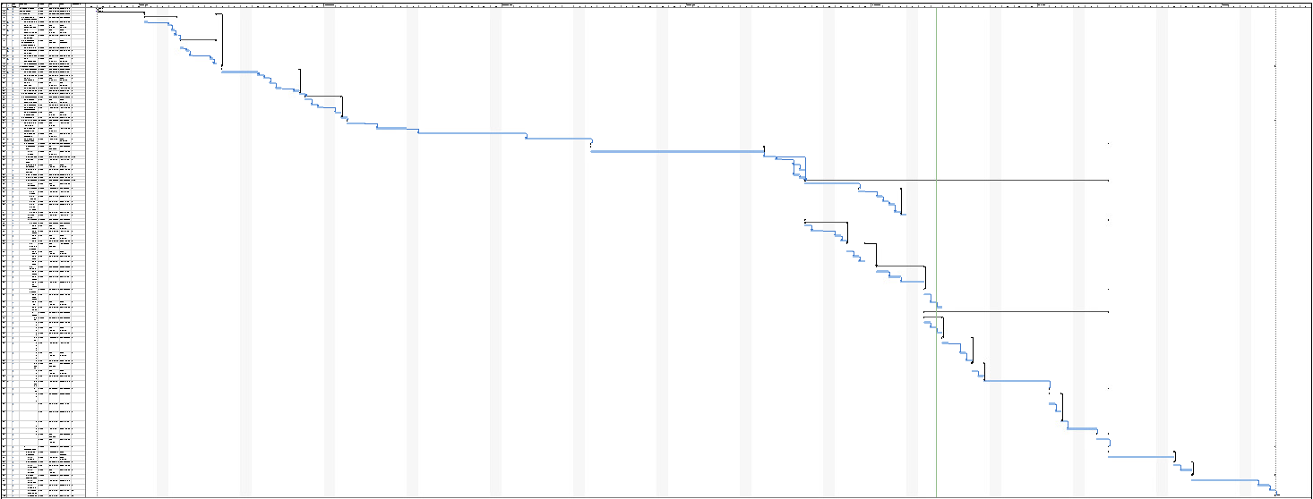

APPENDIX 2: USER MANUAL

User Manual


Table Of Contents

System Overview 2
Hardware 2
How to wear 2
Cleaning 3
Set Up 4
Safety Guidelines 4
WARNING 4
CAUTION 4
Device Description 5
Operating Instructions 5
Troubleshooting 6
Device’s Automatic Sleep Mode 6
General Info and Specifications 7
Sensors and Components 7
Materials 7
Battery 7

System Overview
A guiding tool for certified behavioral therapists/caretakers monitoring individuals with autism spectrum disorder (ASD) to aid in detecting early onset signs of an autistic meltdown.
CAREband is not intended for medical diagnosis or treatment of autism spectrum disorder.

Hardware
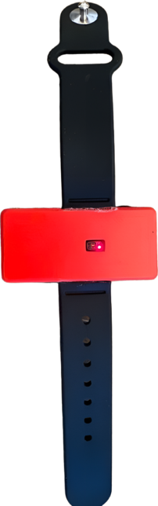
The CAREband box includes:

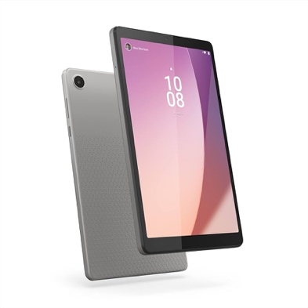
Lenovo Tablet Heartrate Monitor Wristband

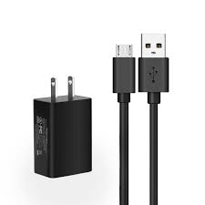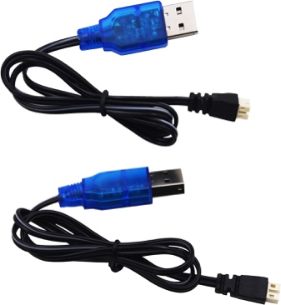
Tablet Charger Battery Charger

How to wear
CAREband should be worn snug around the wrist. The sensor should be placed on top of the wrist roughly one finger length away from the beginning of the hand and one centimeter next to the ulnar styloid process (as shown in the following images). The monitor should be snug on the wrist so that the sensor is flush with the skin.
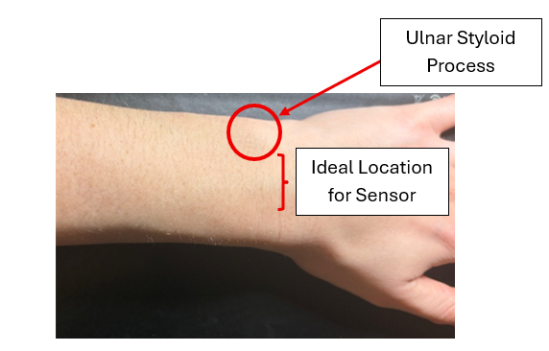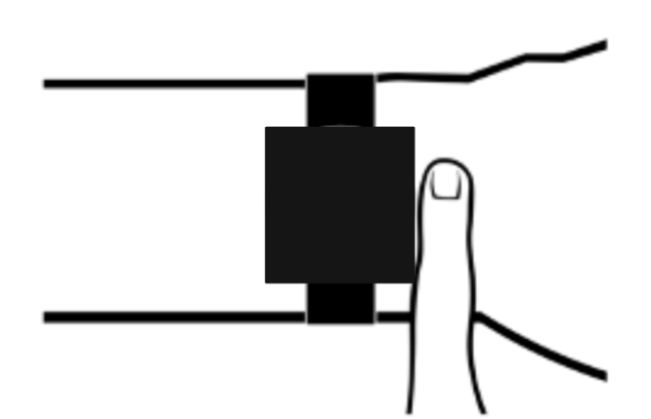
This device is designed to wear for multiple hours at a time; however, we do not recommend extended or all-day wear. It should be removed after the school day is over and should not be worn in cases that the wristband may be submerged in water.

For optimized heart-rate tracking:
- Place the housing component on top of the wrist, ensuring that the sensor is in contact with the skin. It is important to place the device in a spot where wrist movement will not interfere, otherwise the data collection may be inaccurate.
- If the device is not sitting snug, try tightening the wristband. The wristband should not be constricting enough to cut off blood flow.
- It is important to note that heart rate readings are different for every individual and may vary out of expected range due to several factors including skin tone.
To fasten the band:
- Place the housing/sensing device in the desired wrist position.
- Utilizing the silicone wristband, pick the desired hole that will provide the best fit and insert the connector into the hole.
- Once it is connected, slide the excess wristband into the loop and tuck the material away.
As shown on the user below:
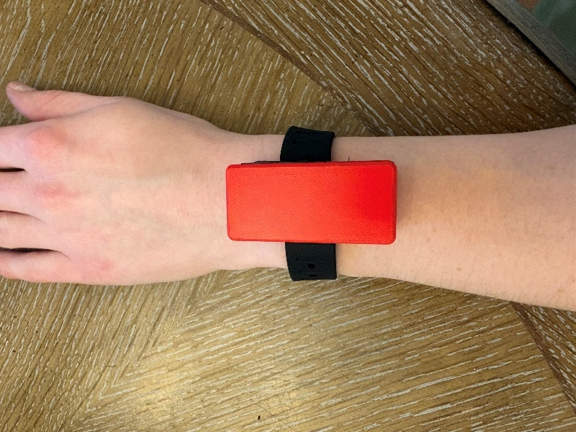

Cleaning
This device is designed to be cleaned and sanitized on a regular basis with common household cleaners.
- It is important to sanitize on a regular basis, at the end of each day, and before switching between users.
- If the device gets wet remove immediately, let it dry completely before putting the device back on.

Set Up
It is important to collect a baseline heart rate for each individual, every time the wristband is put on. This ensures accurate data collection and allows for the warning to be personalized to each user.
- Try to keep the individual as still as possible during initialization.
- Ensure the skin is dry and clean.
- Ensure sensor sits flush with the skin and wristband is snug.

Safety Guidelines

WARNING
DO NOT charge the battery while the battery is connected to the circuit board. Disconnect the battery from the circuit and then charge the battery using the given charger.
CAREband is not waterproof or water-resistant. Submerging in water or long periods of being in contact with water will cause the device to stop working and can cause risk to the user. DO NOT use in or near water.
This device is NOT data secured; there is very poor encryption which poses a potential risk that data may be able to be accessed if breached and heart rate data collected may be stolen.

CAUTION
CAREband is not a medical-grade device and should not be used to treat or diagnose ASD or any other disease.
It is important to note the device has multiple precautions before use.
This device is not medical grade. The heart rate data collected may provide inaccurate data and should be checked by a healthcare professional if there are any concerns.
Individuals with sensitive skin or those who wear the device for an extensive amount of time may be prone to rashes, allergic reactions, or skin irritations. If this occurs, stop wearing the device. To prevent this, ensure cleaning the band thoroughly, check to make sure it is not too tight, and keep it dry.
Skin tone may affect the accuracy of the heart rate data due to how the sensor’s light source penetrates through the skin. It is important to note that the device may still provide heart rate values; however, they may be out of the normal expected range (50 - 120 bpm).
False alerts may occur due to a natural increase in heart rate caused by physical activity. It is important to observe the individual and use background medical knowledge to determine whether intervention is needed. Other false alerts may be due to device malfunction.
Battery life may not last as long as expected due to continuous data collection, poor battery health, or having a faulty component. If the battery dies, data collected will no longer occur, and a new battery will have to be installed.
The device will shut off and stop collecting data if the device has inactive heart rate values for more than 1 minute. It is important to ensure the wristband is snug to the skin’s surface to ensure the device is working and will not power off.

Device Description
A wearable wristband embedded with a PPG sensor that detects heart rate spikes linked with ASD meltdowns. The device pairs with an android tablet to collect data and deliver an alert to a caretaker if the individual’s heart rate has spiked above a 22% threshold set from a collected baseline value.
During setup, the device records a baseline heart rate. An alert is triggered when heart rate exceeds 22% above baseline, and alerts are sent to the connected tablet. Once the alert is received, the caretaker may intervene and calm the child down, which will prevent the risk of an ASD meltdown and protect the child.

Operating Instructions
Setting Device Hardware Up
- Ensure device tablet is on, and the CAREBand app is displayed on the screen.
- Open Device housing by pulling apart the magnetized upper and lower housing compartments.
- Plug in the battery provided to the Arduino board, ensuring that the red wire of the battery is attached to the red wire of the Arduino board and that the black wire of the battery is attached to the black wire of the Arduino board.
- Place the battery on top of the Arduino board allowing it to be sandwiched between the top and bottom of the housing compartments.
- Confirm Device is on by checking the red sensor light is illuminated (as shown in the image below).
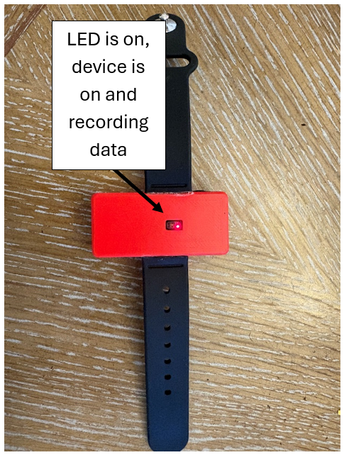
- Place the device on the individual, as depicted in the How To wear section of this user manual.

Troubleshooting

Device’s Automatic Sleep Mode
The device includes an automatic “sleeping mode” where the sensor temporarily shuts off if it doesn’t detect a heart rate for more than 1 minute. This is designed to conserve battery life. If this occurs:
- Open the device housing.
- Temporarily move the battery (do not unplug it) so that the Arduino Board is exposed.
- Press the reset button.
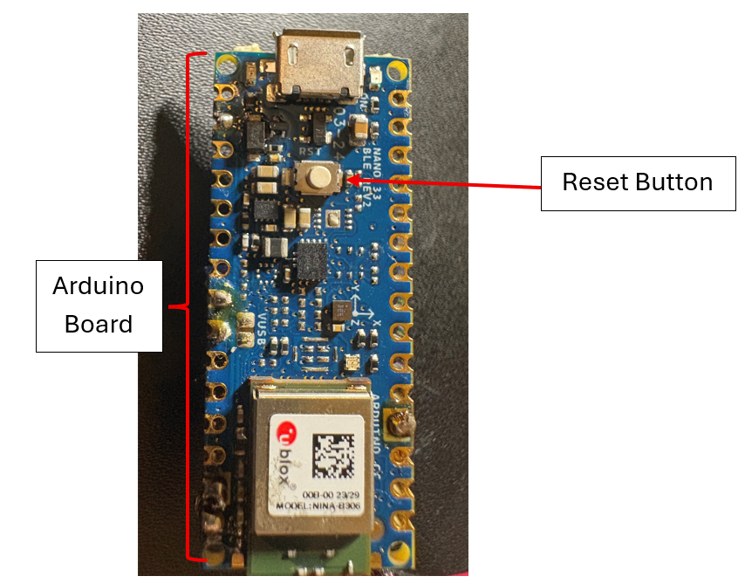
- The Red LED light from the sensor should then be illuminated; this confirms that the device is on and taking data.
- Put the battery back in place and secure the top of the housing back onto the device.

General Info and Specifications

Sensors and Components
The following sensors and components are contained in the device:
- Arduino Nano BLE rev2
- PPG Sensor MAX30102
- Lithium Polymer Battery

Materials
The housing component was 3D printed using polylactic acid (PLA), which is generally known to be biocompatible and is used in a variety of medical applications. The wristband is made of silicone, which is hypoallergenic and should not cause irritation for people with sensitive skin.
Magnetic strips and epoxy are used to keep the housing component closed and to attach the wristband together. However, these materials will not be in contact with the user’s skin; they should not be irritant.

Bluetooth Connection
The Bluetooth connection on the device has a range of about 50 meters; however, range can vary due to obstacles found within the space, as well as other Bluetooth devices found. If data stops being read, try to move back in range of the tablet to reconnect the Bluetooth connection.

Battery
The CAREBand device uses a 3.7 V rechargeable lithium polymer (Li-Po) battery with an approximate capacity of 300 mAh. The battery’s typical operation time lasts from 4 to 6 hours of continuous monitoring. This may vary depending on the Bluetooth data transmission frequency, continuous usage of the PPG signal acquisition sensor, as well as the batteries condition and age over time. When the battery level is low, the device may lose Bluetooth connection, stop collecting data, or power off.
Battery Charging Instructions:
- Disconnect the battery from the device prior to charging.
- Use the provided battery compatible charger, ensuring that the battery terminals are connected to their associated terminals of the charger.
- Plug the charger into either a computer USB or an outlet USB (please note that outlet USBs are not included with the device).
- Leave to charge for 1 to 2 hours.
NOTE: Do not overcharge the battery to avoid battery overheating, potential safety hazards, or reduce the battery lifespan.
Safety Guidelines & Information:
- Do not crush, puncture, or expose battery to high temperatures.
- Do not use device if battery appears damaged, expanded, or swollen.
- Keep the battery away from moisture, wet surfaces, and water.
- Only use battery compatible and approved charging cables and equipment.
- Do not store the battery empty, always charge before storing.

APPENDIX 3: PROJECT HAND-OFF PACKAGE
- CAREBand System Overview & Operation
CAREBand is a wearable wristband system that is designed to monitor heart rate (HR) in children with autism spectrum disorder (ASD) to detect early signs of meltdowns. The system currently uses a photoplethysmography (PPG) sensor (MAX30102) to continuously monitor and collect heart rate data. The collected HR data is then transferred via Bluetooth to a caregiver interface (tablet). The current prototype is implemented using an Arduino for timely project testing, validation, and completion. A threshold-based algorithm is used to detect increases in HR that are approximately 22-29% above baseline HR and triggers an alert to notify therapists and caregivers for early intervention before a meltdown occurs. The intended CAREBand final design would include a transition to an nRF52832 chip directly integrated into a printed circuit board (PCB) to improve power efficiency, reduce sizing, and enable full system integration.


Figure 1. Process map outline for wristband preparation and usage

The CAREBand device system operates by integrating sensing, processing, and communication components to allow for real-time data monitoring and collection as well as an alerting system for caregivers. As shown in the process map in Figure 1, the CAREBand system operation workflow starts with device setup and baseline HR calibration, and finally, data collection and monitoring. The CAREBand hardware supports this system through its electrical system shown in Figure 2 that includes the MAX30102 PPG sensor that is connected to the Arduino and the power components for physiological data collection and transmission.
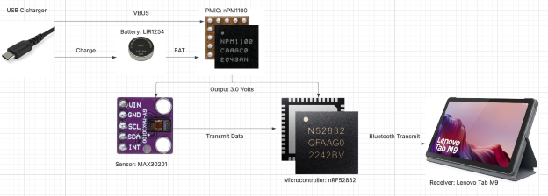
Figure 2: Electrical Components chosen and how they Integrate into the circuit.


Figure 3: Process map of main components of software.

Additionally, the software workflow shown in Figure 3, demonstrates how HR data is processed, transferred (via Bluetooth), and analyzed using the threshold-based algorithm developed to detect potential meltdowns. In Figure 4, the CAREBand system integration is shown to demonstrate communication between the wearable device and the caregiver interface (tablet).

Figure 4: Process map Outline for software.

- Testing and Validation
Testing and validation procedures and results are included within the Requirement Traceability Matrix (RTM), which includes verification of the HR detection accuracy, Bluetooth communication functionality, and system usability. Table 1 shows the current project evaluation based on each requirement included in the RTM.

Table 1. Satisfaction of Each Requirement that was Included in the Requirement Trace Matrix
ID Number | User/Stakehold | Requirement | Satisfaction
1.0 General | Device provides reliable HR monitoring of HRs between 30-210 BPM | Device will have a % error of <10% (this % error is based on clinically accepted wrist HR monitoring devices.
2.0 Function & Features | Detects increase in heart rate and sends a warning response to clinicians | Warning is sent to clinician's interface when the heart rate increases by 22% | Satisfied  Usability test was performed.
 | Can withstand everyday wear for active children | Device will be sturdy enough to withstand daily hand movements and mobility | Not Satisfied  Device stays together; however, a final design would need to be stronger.
 | Device will account for physiological differences among patients | Device will include a normalization process during set-up | Satisfied  Usability test was performed among multiple subjects, collecting a baseline for each.
 | Device will be evaluated based on user input for improved modifications | Device will meet CAPA requirements for user evaluation
3.0 Ergonomics & Physical | Device should be comfortable and not disruptive to daily tasks | Wrist band should be composed of a material that smooth and doesn't retain heat (to prevent sensory overstimulation for the patients). | Satisfied  Material is a known, approved wristband material.
4.0 Data | 'Compliance with HIPAA Laws | Device should include technical safeguards to ensure patient confidentiality
 | Follows software life cycle requirements | Device should have risk management documentation
 | Clinical data storage | Device shall store and export 24 hrs of heart rate data
5.0 User Interface | Easy to read/understand | Device indicates the objective heart rate (in bpm) and a warning component when the threshold is exceeded | Satisfied  Software and usability tests were performed.
 | Includes a more rigorous interface for highly specialized clinicians | Device shall include an EKG-like styled graph | Not Satisfied  Could not be done within the scope of the course and the sensor that was used.
6.0 Refurbish/Recycle | Compliance with sustainability | Device shall be designed for end-of-life recycling per WEEE directive
 | Device can be used for multiple patients | The device should be able to be reprocessed, revalidated, and withstand surface disinfection to be utilized for multiple patients | Satisfied  All materials used can withstand disinfectant, if it is done safety and does not expose the electrical components
7.0 Packaging/Labeling | Regulatory compliance | Labeling shall meet FDA requirements | Satisfied  User manual followed all regulation guidelines that were required.
 | Safe transport | Packaging shall protect device from damage in 1m drop test | Incomplete  Packaging was not done within the scope of the course.

- Completed Work
- Functional prototype developed using an Arduino.
- Successful HR data monitoring and collection using the MAX30102 sensor.
- Implementing a threshold-based algorithm for HR increase detection (22-29% increase above baseline HR).
- Successful data transmission to caregiver tablet interface via Bluetooth.
- Successful initial validation testing of the CAREBand prototype.

